HITEC UNIVERSITY TAXILA
OFFICE OF THE PROCUREMENT
Museum Road, Taxila Cantt | Tel: 051-4908146-9 (Ext. 308) | Email: procurement.office@hitecuni.edu.pk
REQUEST FOR QUOTATION (RFQ)

RFQ Ref No: HITEC/PROC/RFQ/2026/2868 | Delivery Location: HITEC University, Taxila Cantt
Issue Date: 15 October, 2026 | SUBMISSION DEADLINE: 21 October 2026 @1200 HRS
Procurement Title: Procurement of Consumables Items

1. SCHEDULE OF REQUIREMENTS & TECHNICAL SPECIFICATIONS
S/N | Detailed Technical Specifications / Items Required |  | Required Qty | UOM
 | Hacksaw Blade | Double sided (1 Feet length ) | 72 Pieces | Nos | 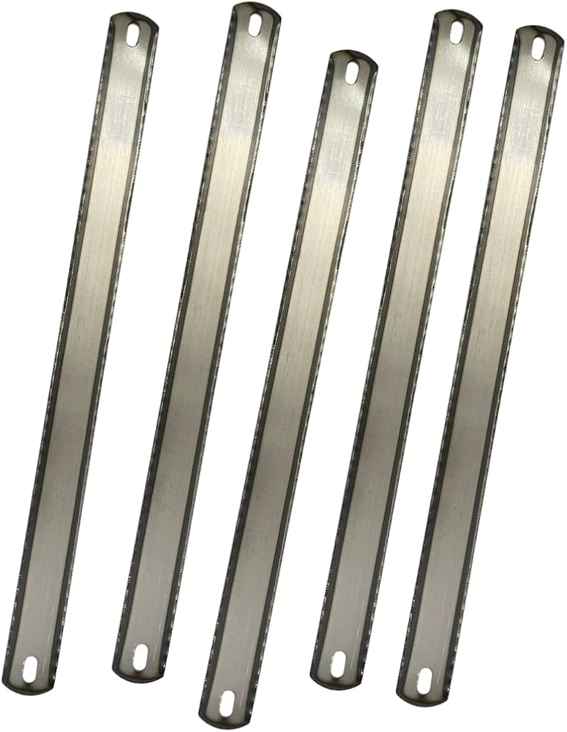
 | Adjustable Tap Wrench Handle | Standard size | 6 Pieces | Nos | 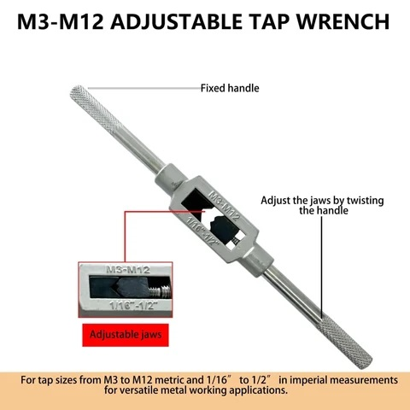
 | Tool Bits | Size = 0.5 inch x 8 inch | 12 Pieces | Nos | 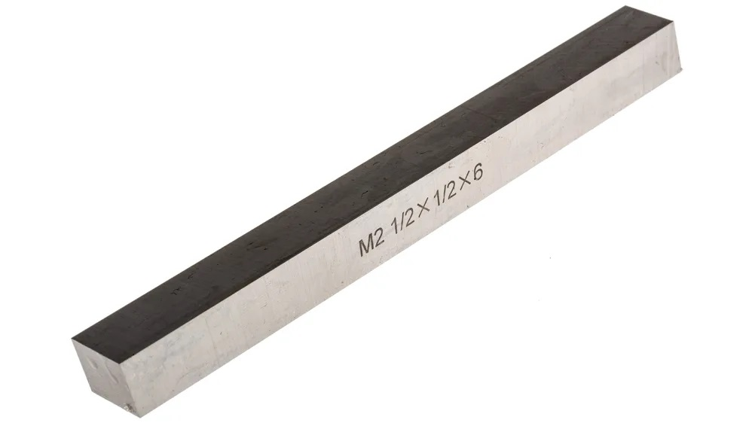
 | Screw Gauge (Micrometer) | Range = 0-25mm | 5 Pieces | Nos | 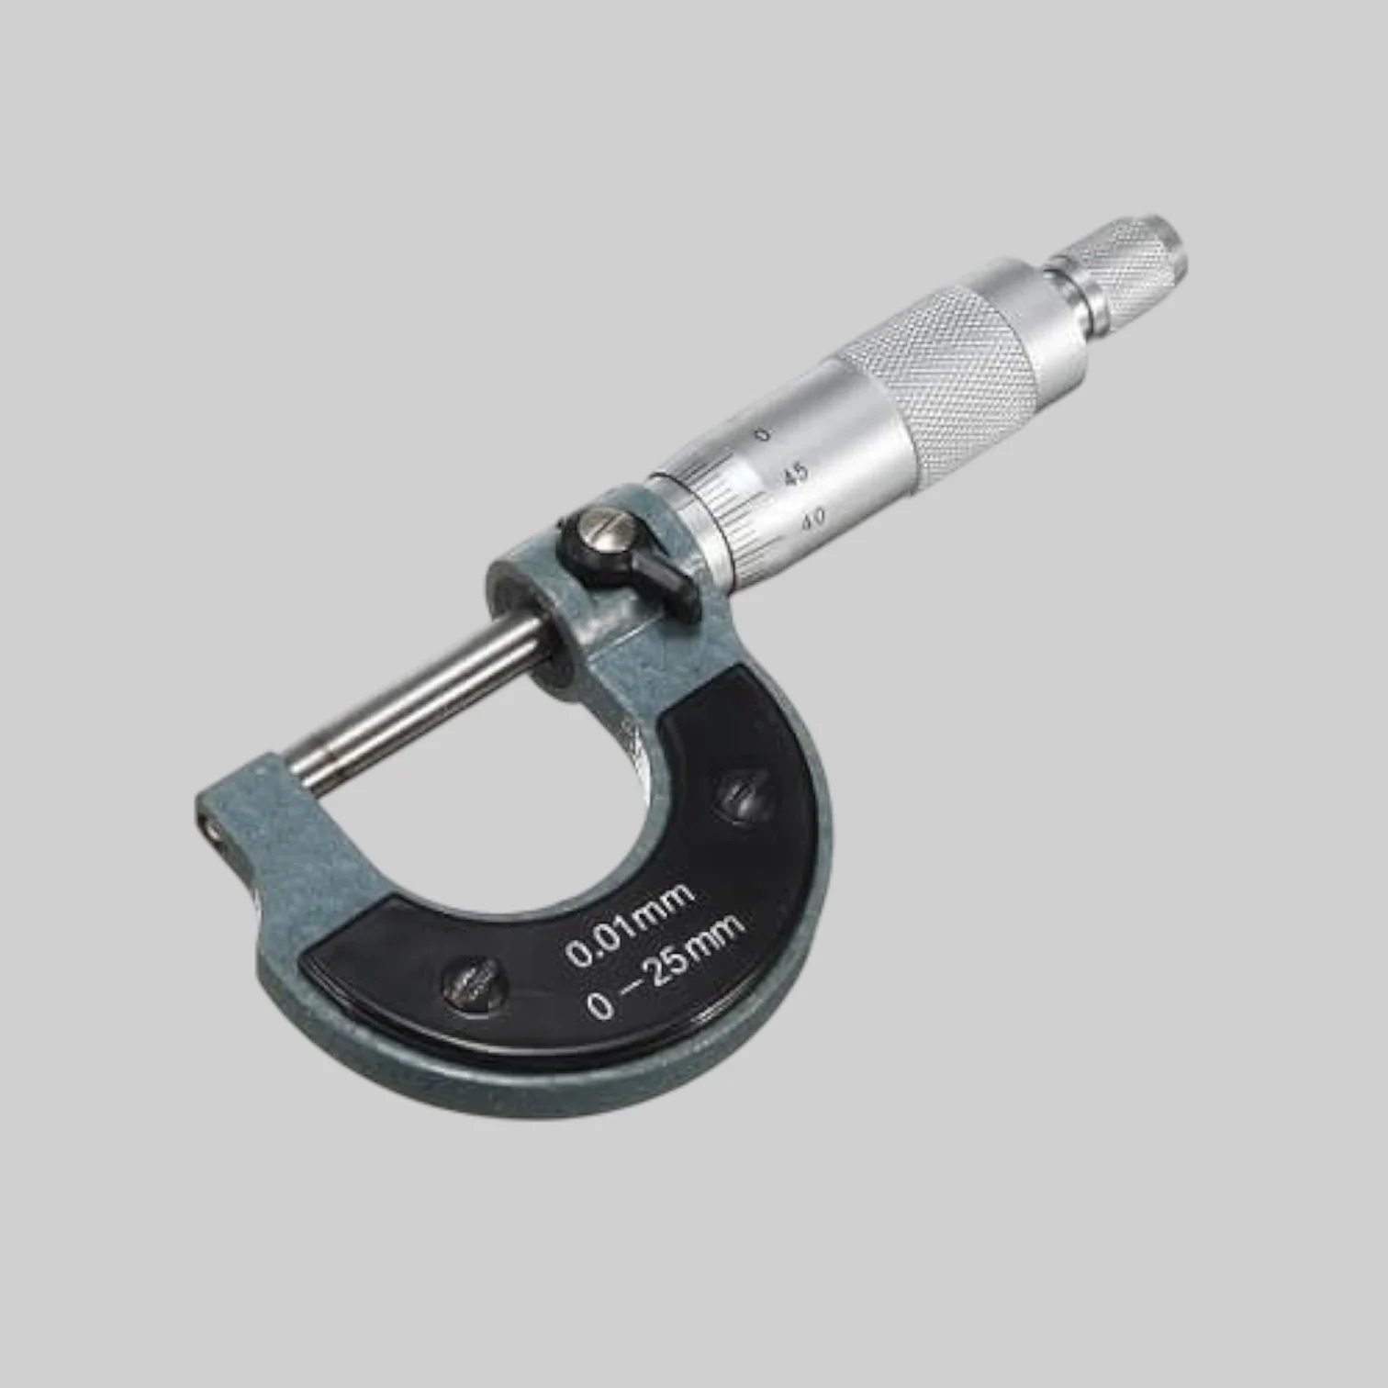
 | MS Polish Rod | Dia = 1 Inch | 50 Kg | KG | 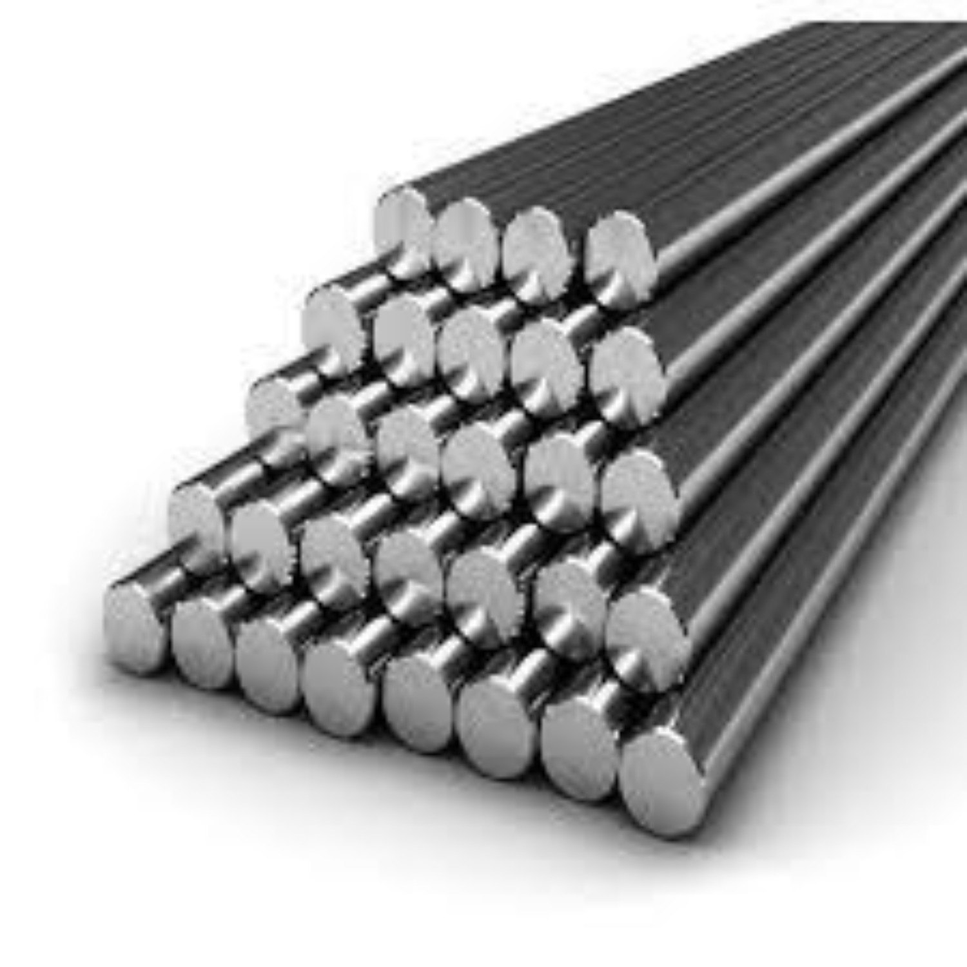
 | Ms Iron Strip | 5mm x 2 Inch | 50Kg | KG | 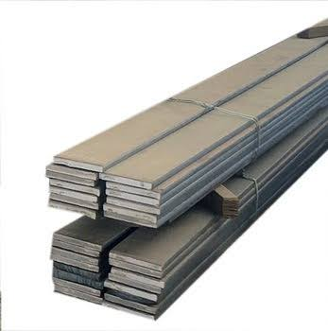
 | Power Hacksaw Blade | 1 Inch x 14 Inch | 2 Pieces | Nos | 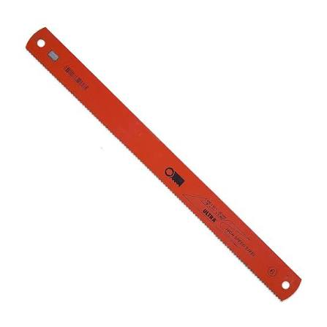
 | End Mill Cutter | Diameter (4mm, 6mm, 8mm, 10mm, 12mm) | 2 Pieces Each (10) | Nos | 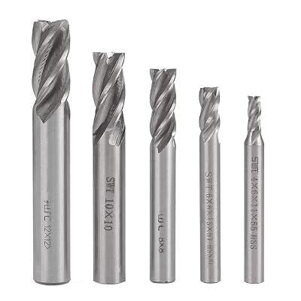
 | Engine Oil | HD-50 | 40 L | Liter | 
 | Digital Infrared Thermometer | Max Range = 550°C | 1 Piece | Nos | 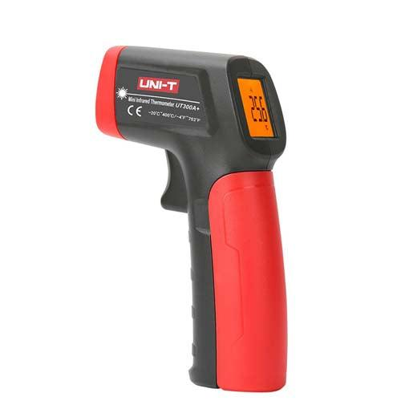
 | Emery Paper | no 1 | 36 Pieces | Nos | 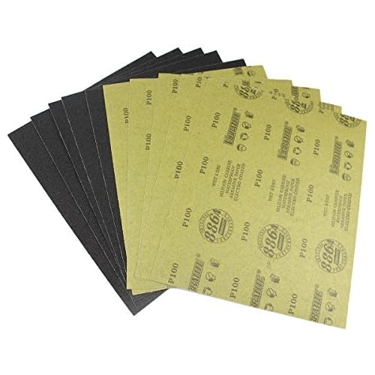
 | Drill Bit | Diameter (5mm, 10.5mm 20mm, 18mm, 22mm) | 2 Pieces Each (10) | Nos | 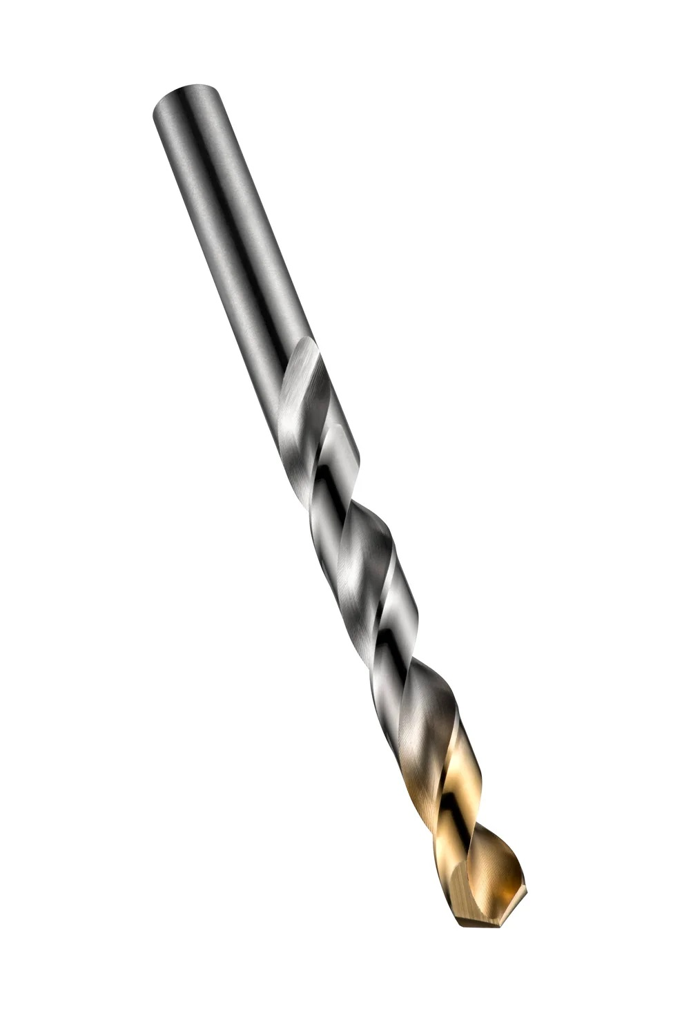
 | Digital spring scale | Range = 0-50 Kg (continuously reading) | 02 | Nos | 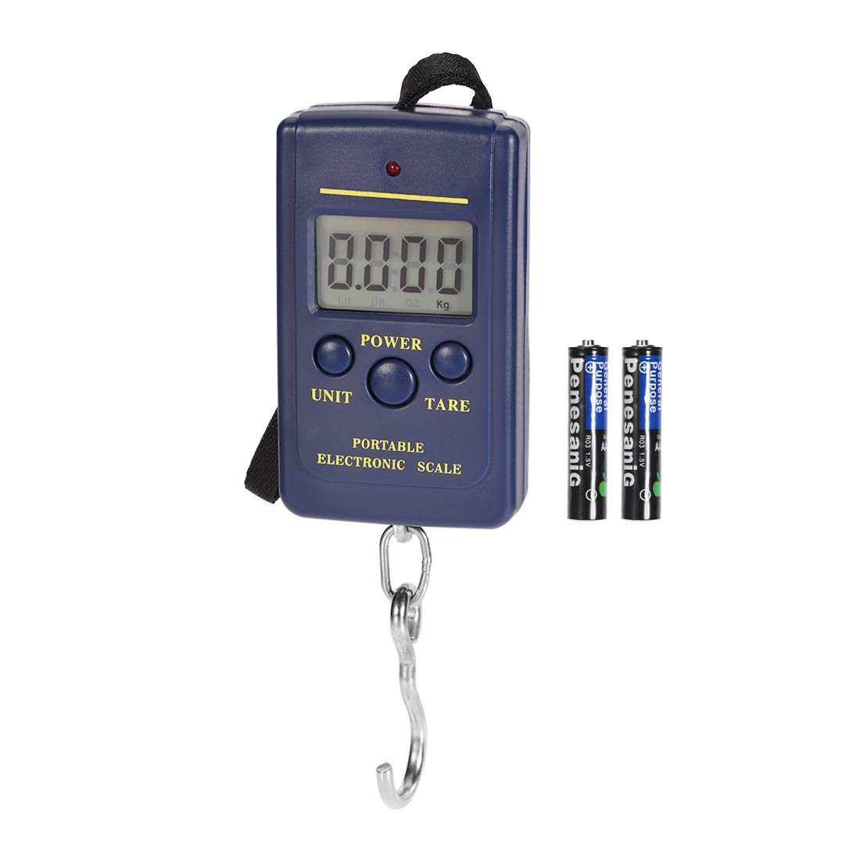
 | Pneumatic Hose PU Pipe | 10 mm OD: Inner size is 6.5 mm | 40 Feet | Feet | 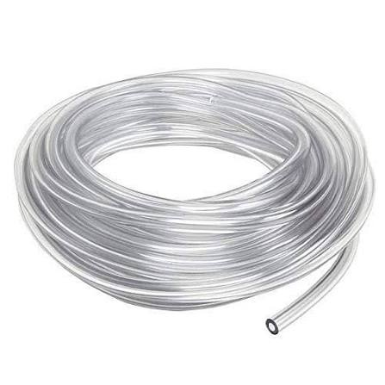
 | Ink (fountain ink) | Blue (60 ml) | 6 Bottle | Nos | 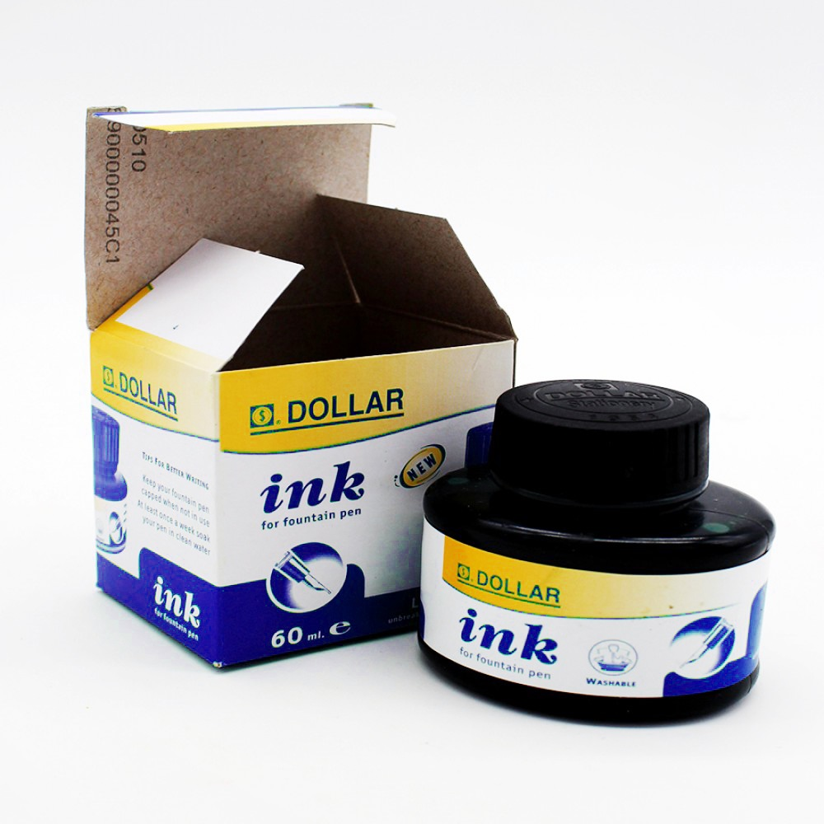
 | Teflon Tape | (12 mm) width | 8 Pieces | Nos | 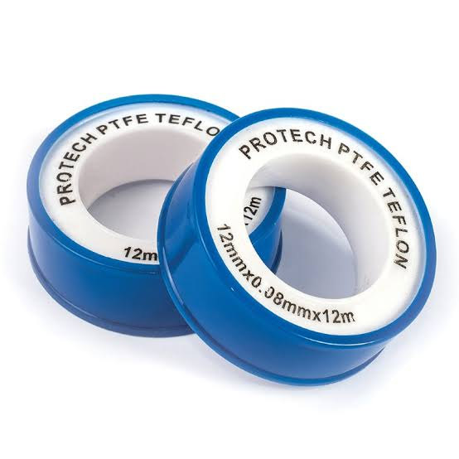
 | Smad Bond | 60 ml Tube | 2 Pieces | Nos | 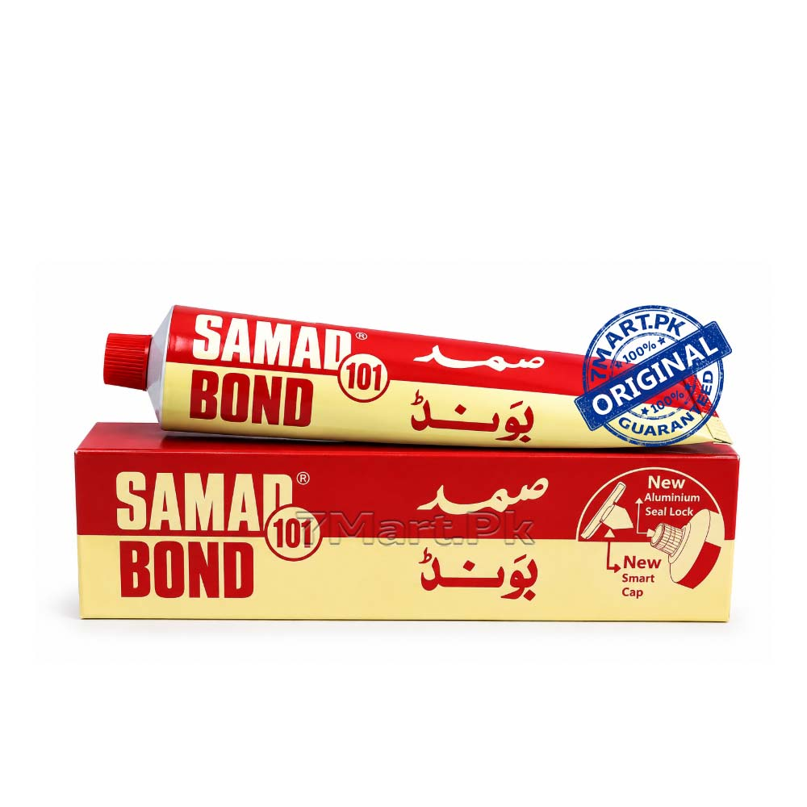
 | Glycol Chemical | Grade 5 | 2 Liter | Liter | 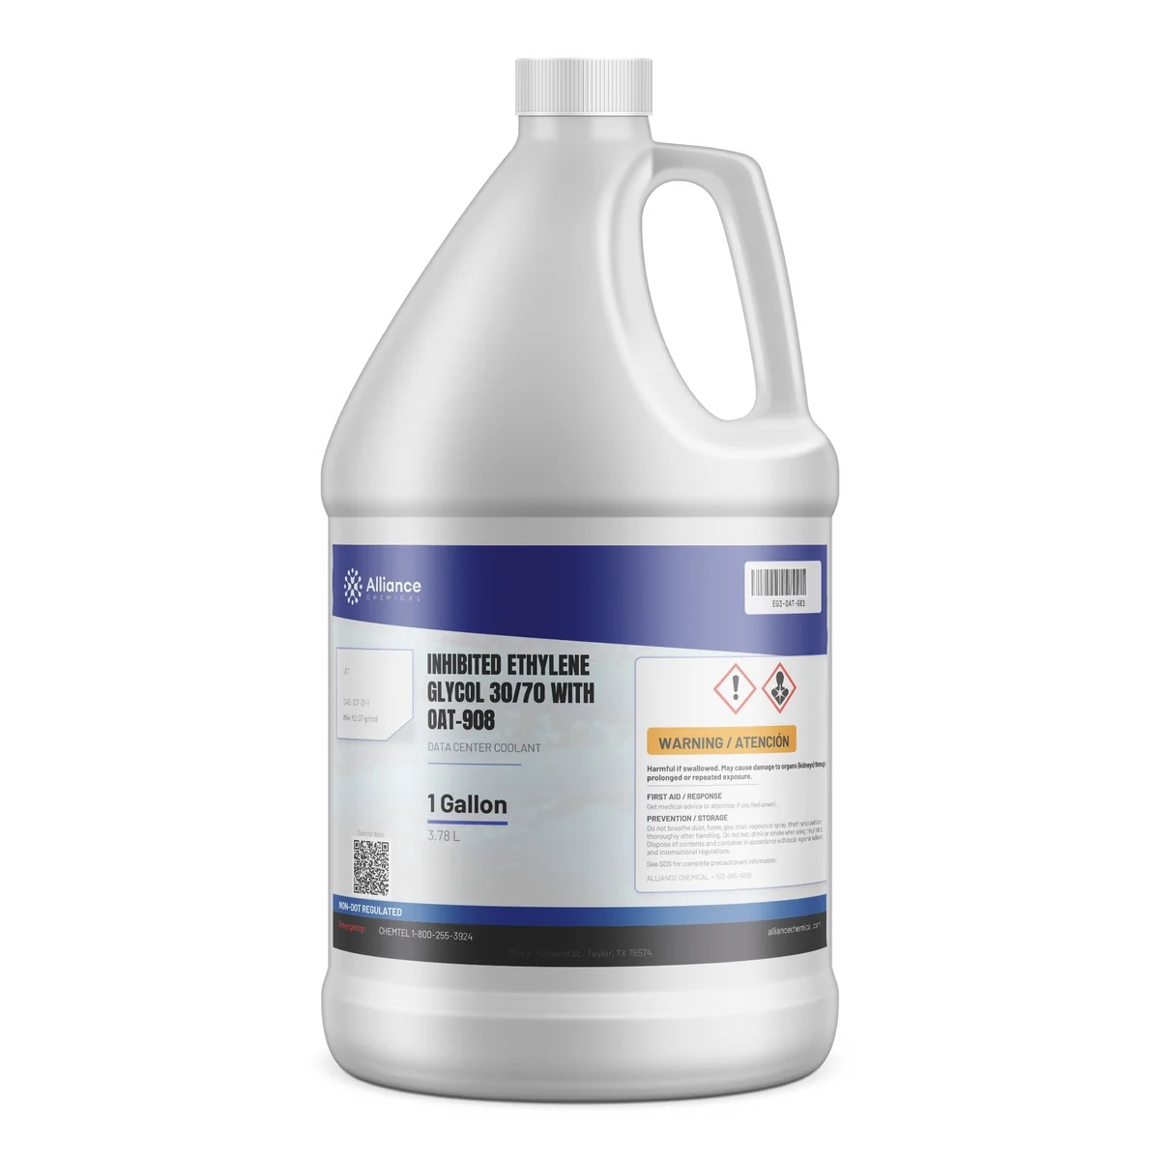
 | Elfi | Tube (20 ml) | 1 Piece | Nos | 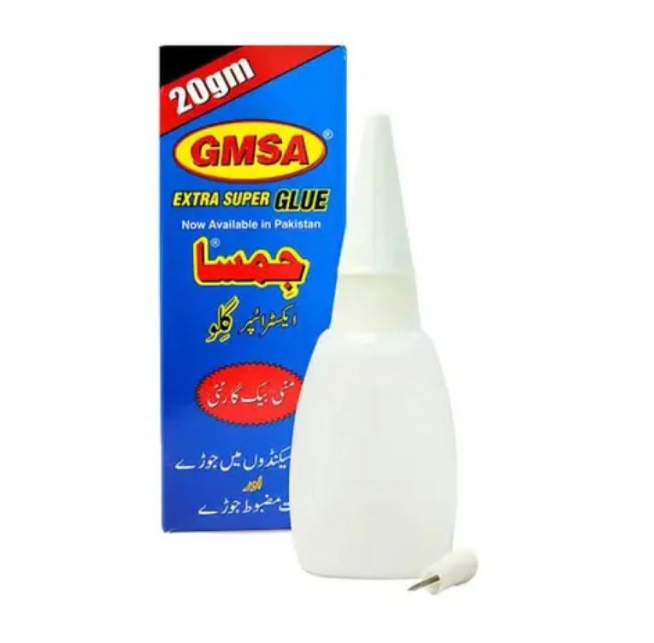
 | Cell (AAA) | Power Plus 1.5 v | 12 Pair | Nos | 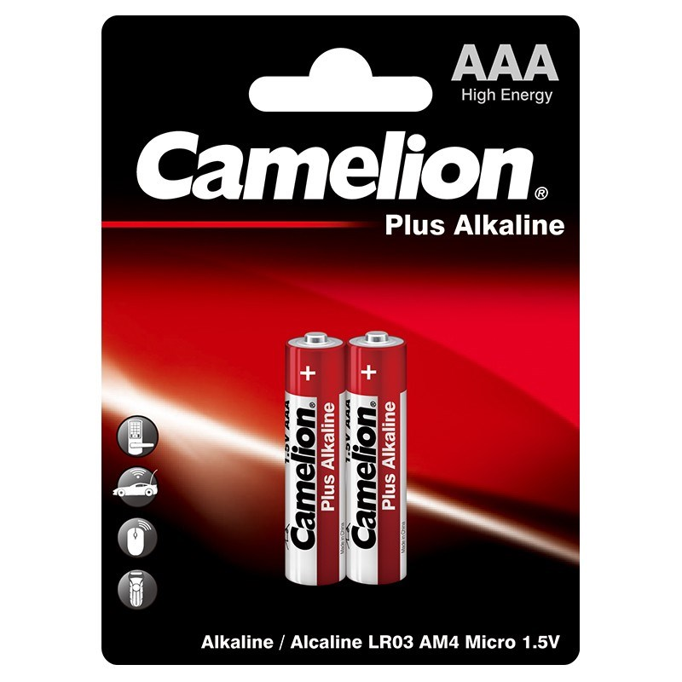
 | Glass Tubes | Dia=10mm L= 1m | 2 Pieces | Nos | 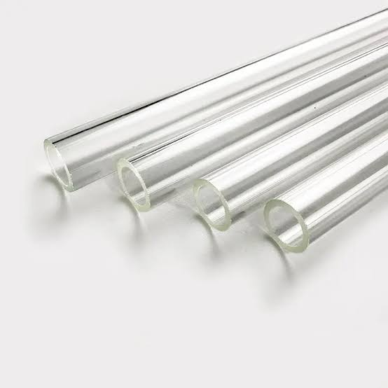
 | Pipe Fitting ( Quick Fitting) | Dia=1 Inch | 6 Pieces | Nos | 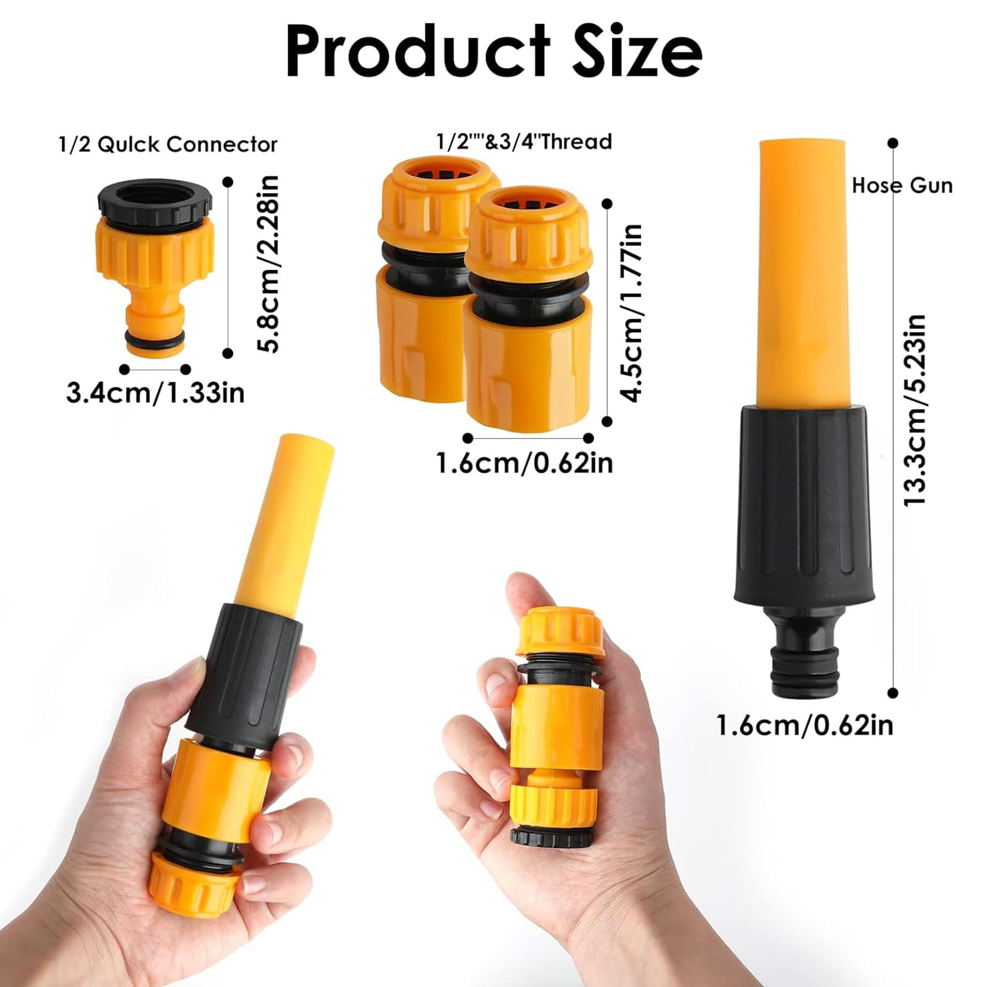
 | Push Connect Pipe Fittings | dia =10mm,5mm | 12 Pieces | Nos | 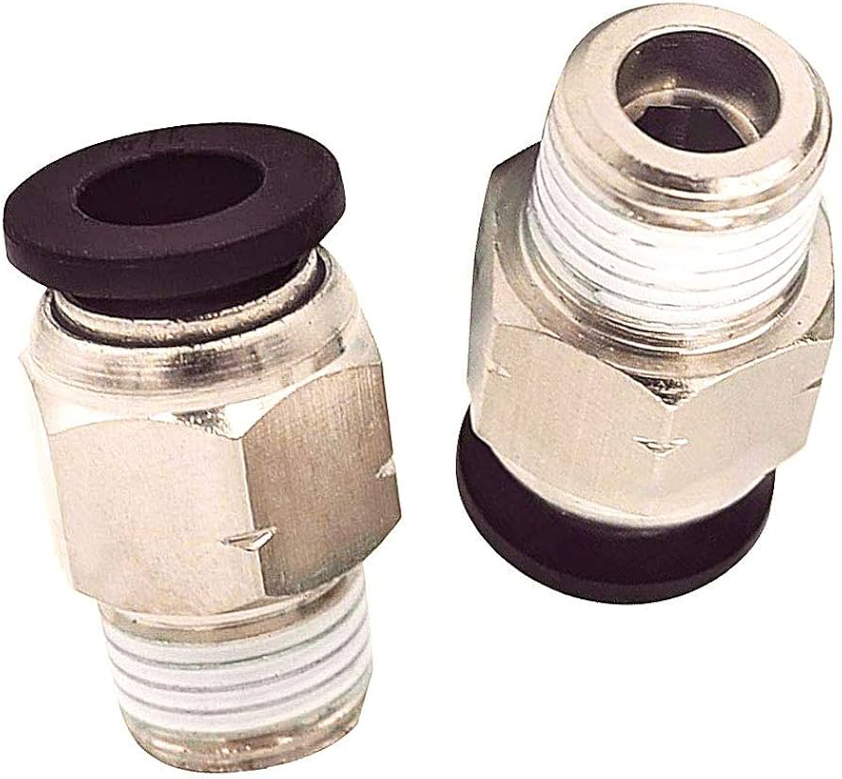
 | Welding Rod (iron) | 2.5mm (12 No) | 2 cotton (8 Pack) 40 kg | KG | 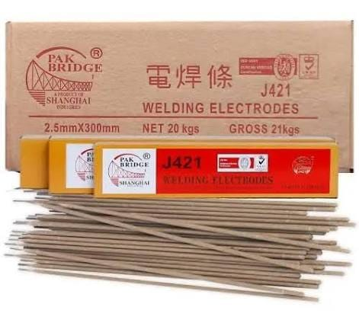
 | Welding Cable with 2 thimble | 16mm | 10 Meter | Meter | 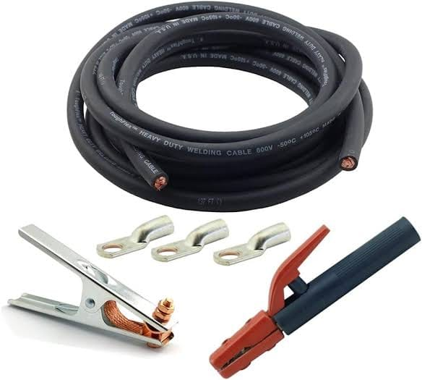
 | Cutting Disks (iron) | 14 Inch | 6 Pieces | Nos | 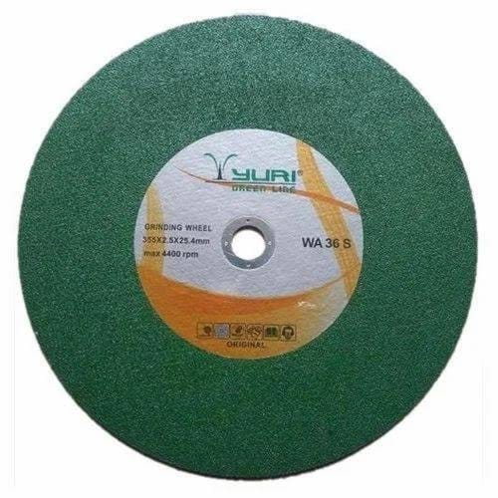
 | Grinding Disks (iron) | 4 Inch | 12 Pieces | Nos | 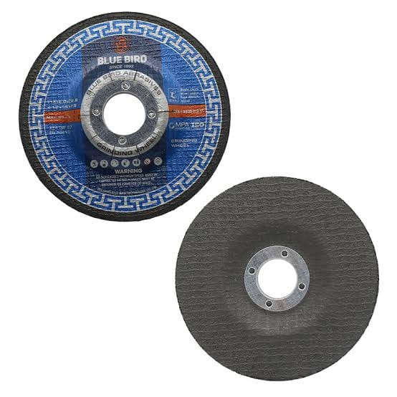
 | Cutting Disks (iron) | 4" (Thicknes = 1mm ) | 36 Pieces | Nos | 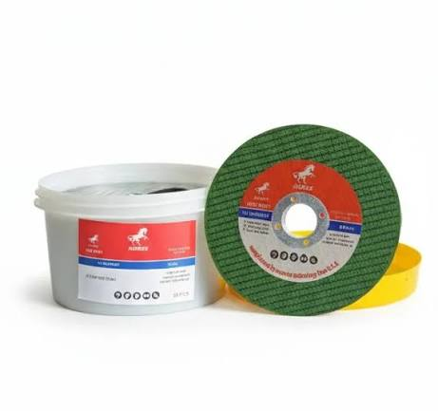
 | leather gloves | Yellow | 24 Pair | Nos | 
 | Oxygen gas cylinder filling | 250 bar | 20 | Nos | 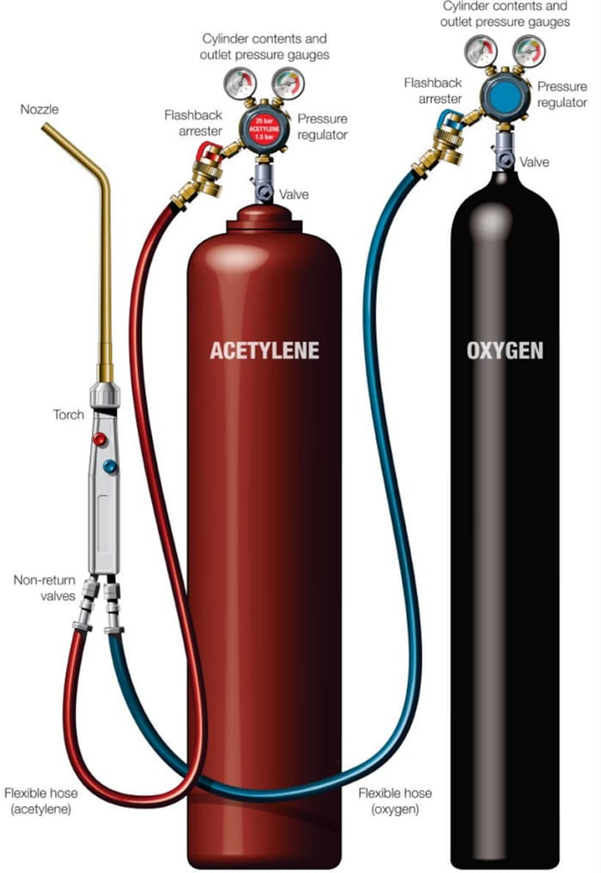
 | Acetylene gas cylinder filling | 2000 bar | 30 | Nos
 | Welding Nozzle | Japani Set | 2 Pieces | Nos | 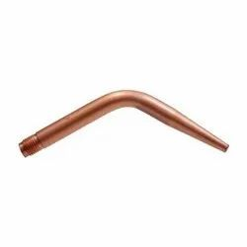
 | Cutting Nozzle | acyteline (1 no , 0 no) | 2 Pieces | Nos | 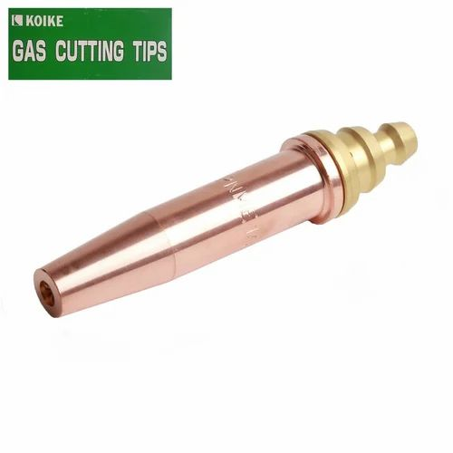
 | Flashback arrester | oxygen+acyteline | 1 pair | Nos | 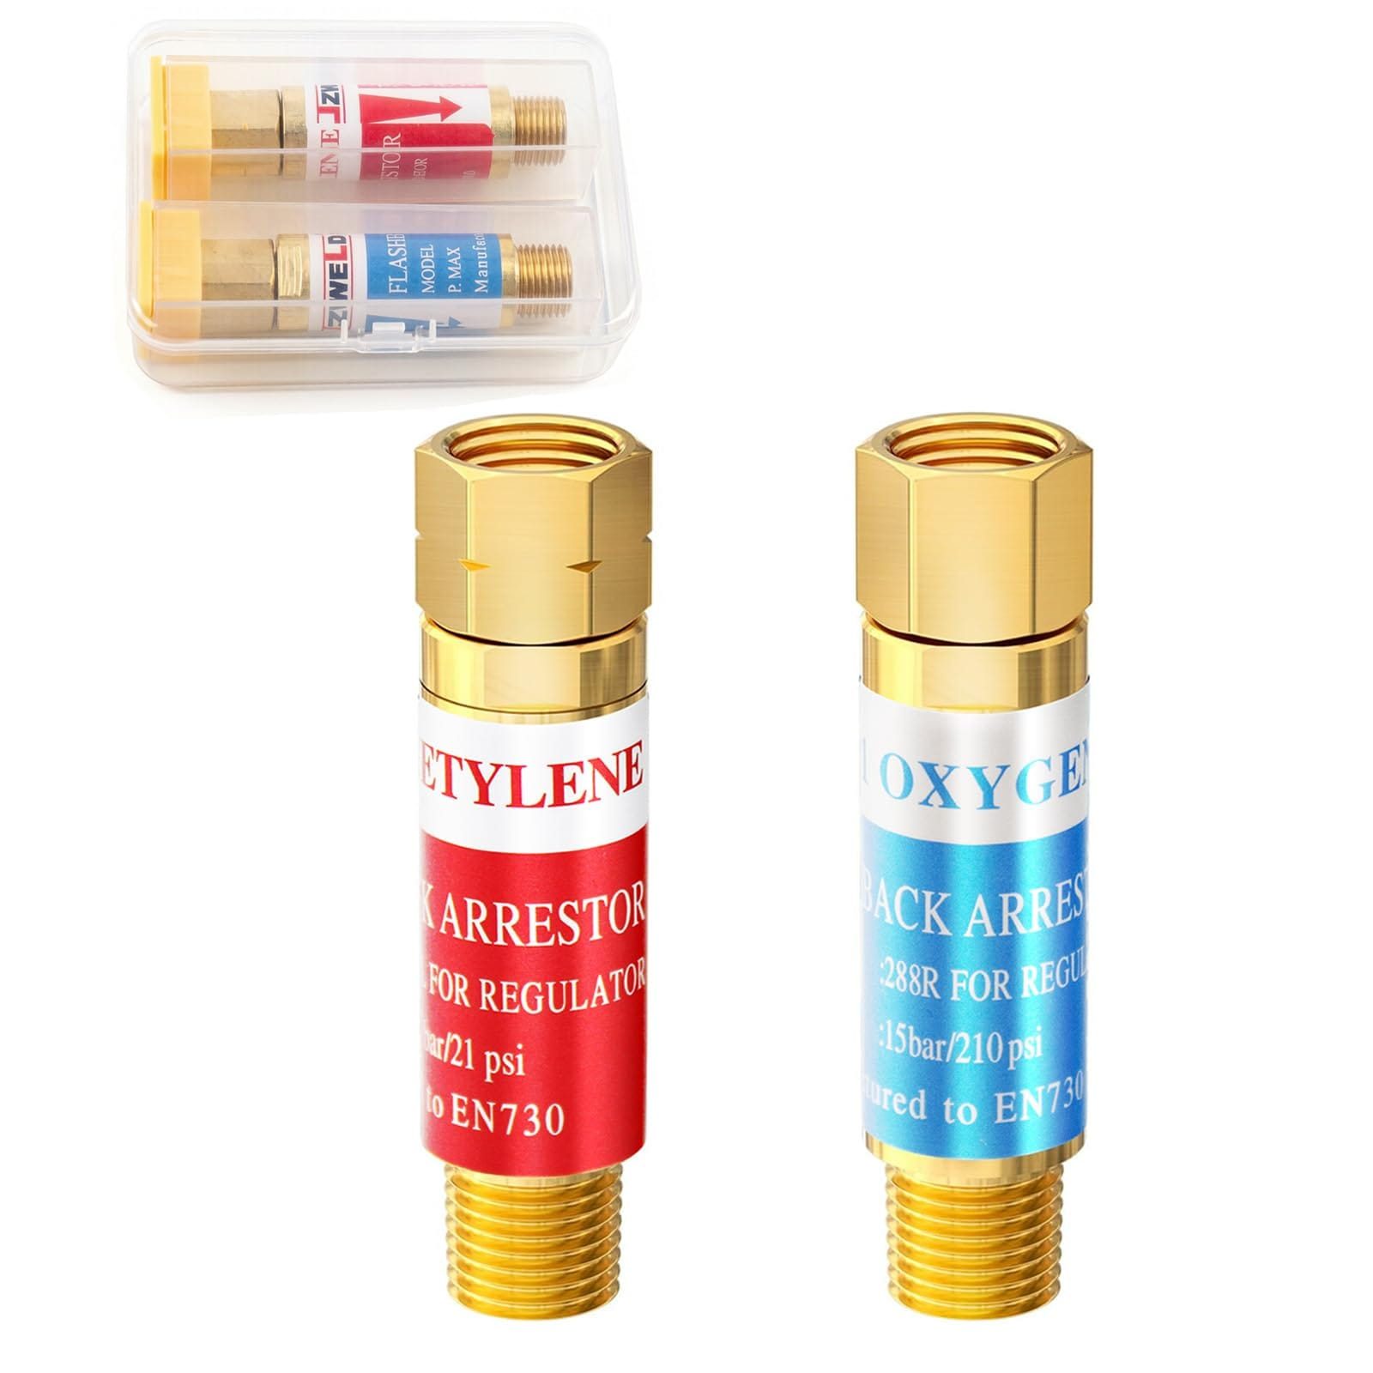
 | Welding Wire Brush | Standard size | 24 Pieces | Nos | 
 | Spark lighter |  | 1 Piece | Nos | 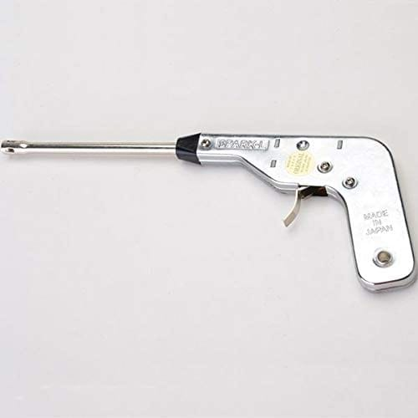
 | Meter Tape | 7 Meter | 1 Piece | Nos | 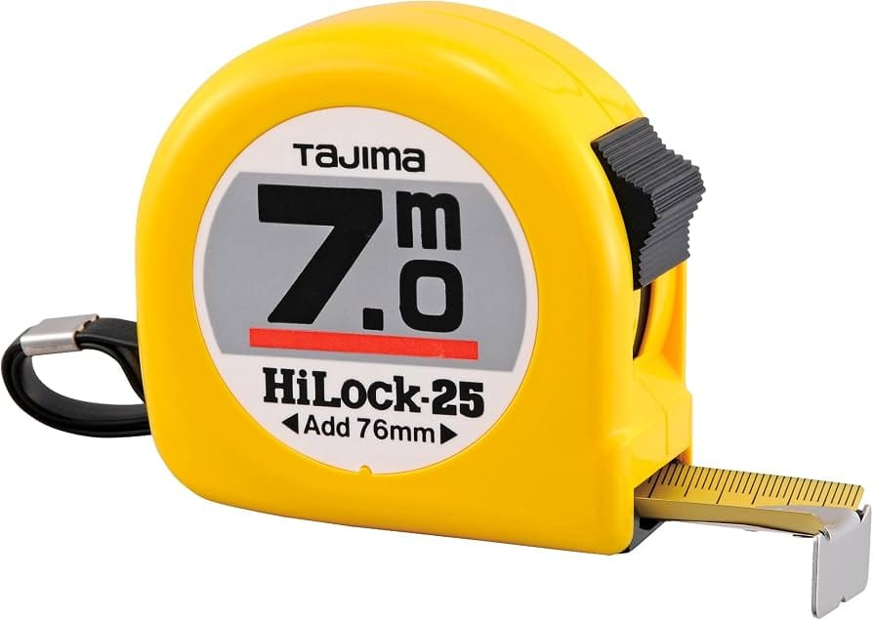
 | Carbon for Baby Grinder 4" | Pair | 2 Pair | Nos | 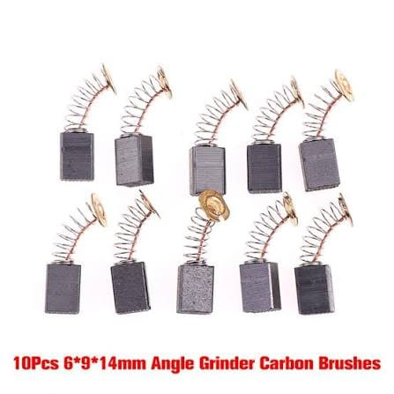
 | Carbon for Power Cutter 14" | Pair | 2 Pair | Nos
 | Saleti | white | 1 Pack | Nos | 
 | Welding Holder | 300A | 2 Pieces | Nos | 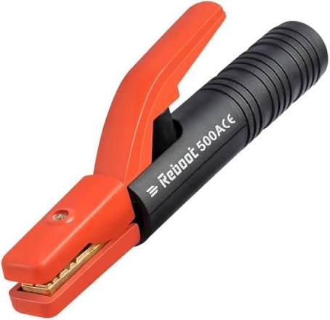
 | Earth Clamp |  | 2 Pieces | Nos | 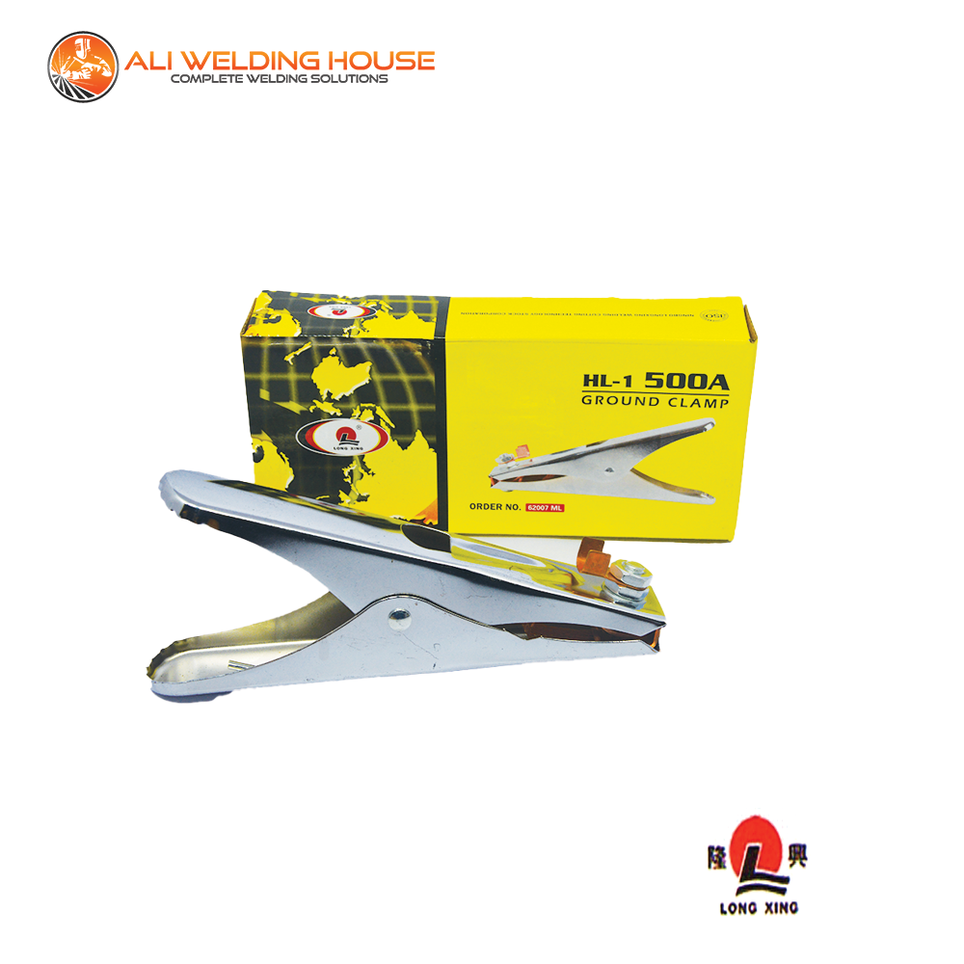
 | Filler Wire | MS | 10 kg | KG | 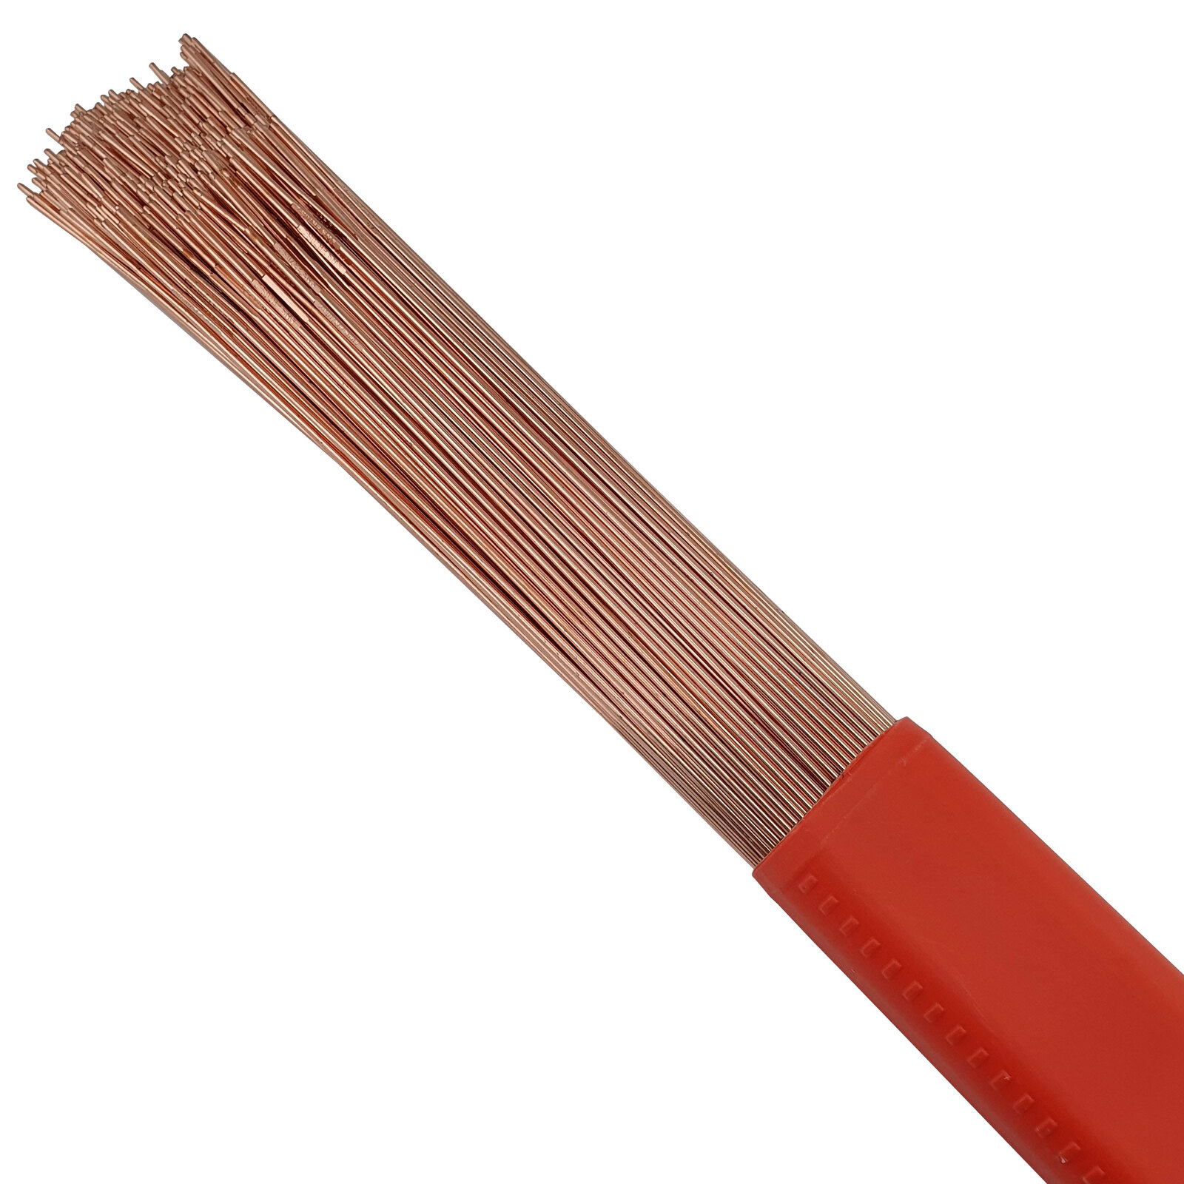
 | Cylinder Valve Key | Oxygen and Acetylene Cylinder large size | 1 Piece | Nos | 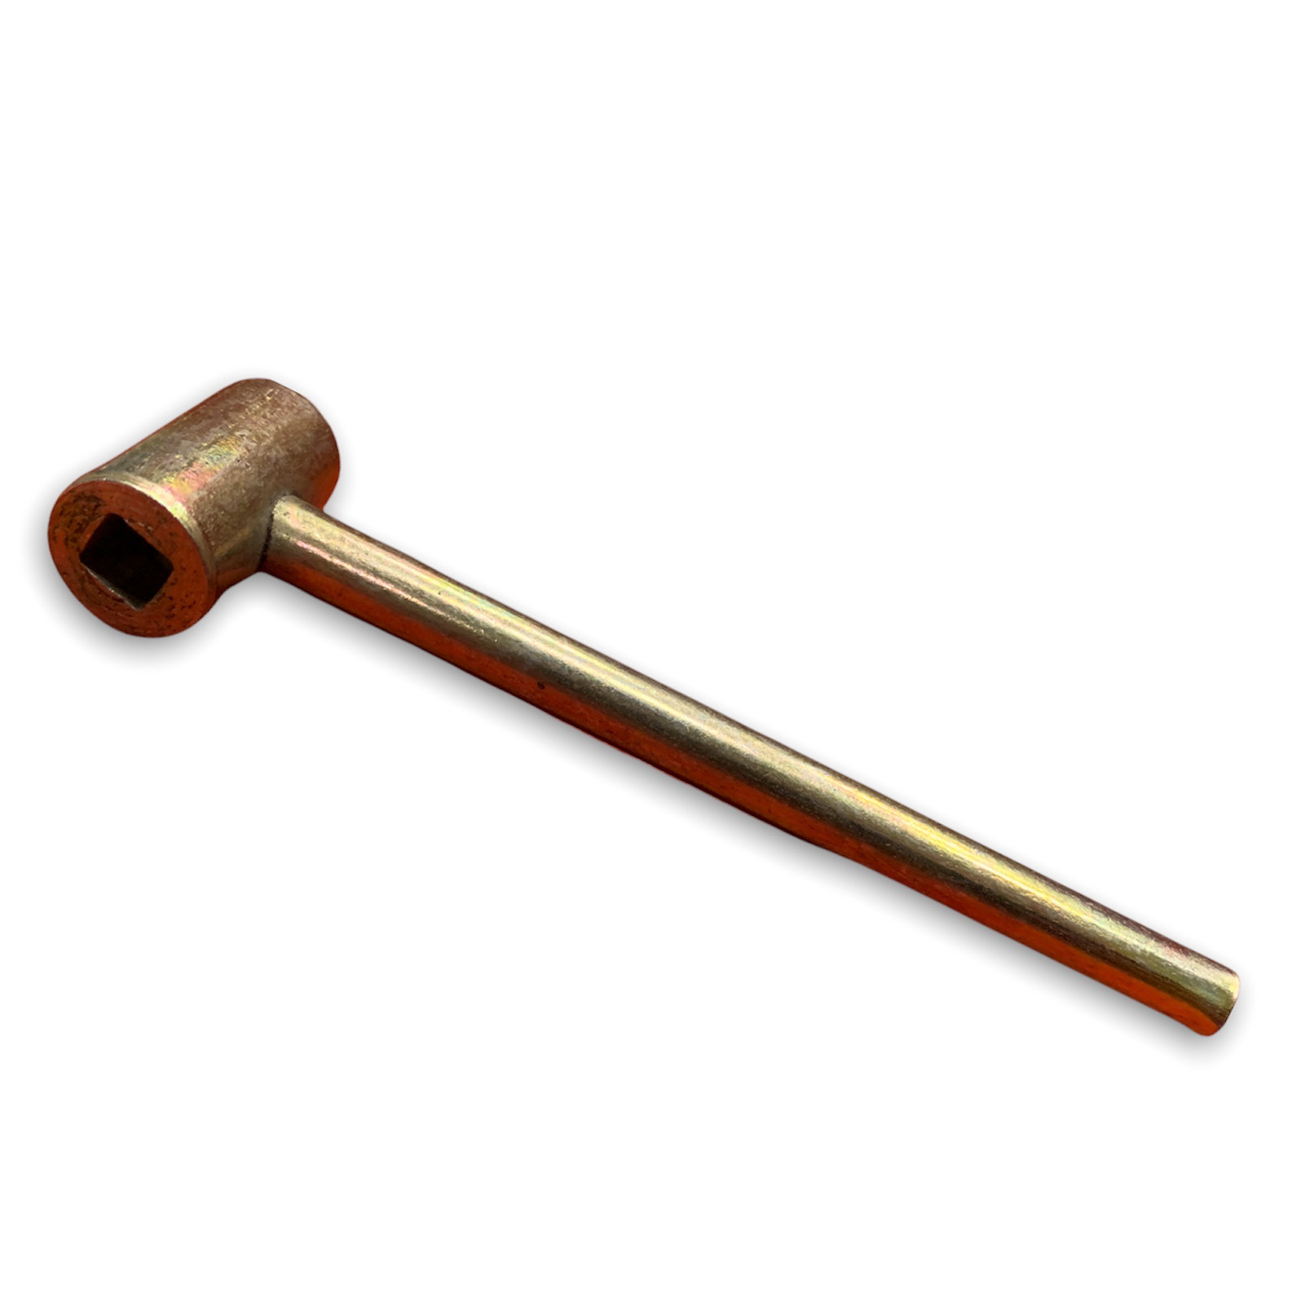
 | Angle Iron | 1 Inch x 1 Inch (Thicknes =3mm) | 50 Kg | KG | 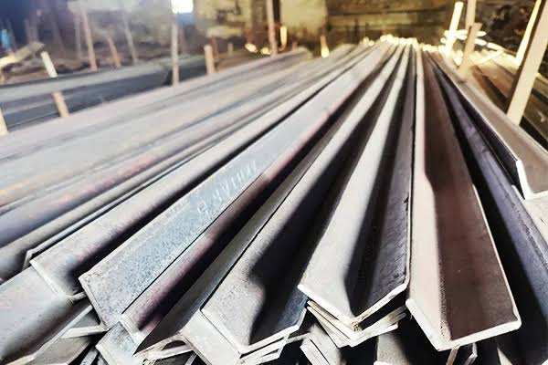
 | Iron Strip | 1 Inch | 40 Kg | KG | 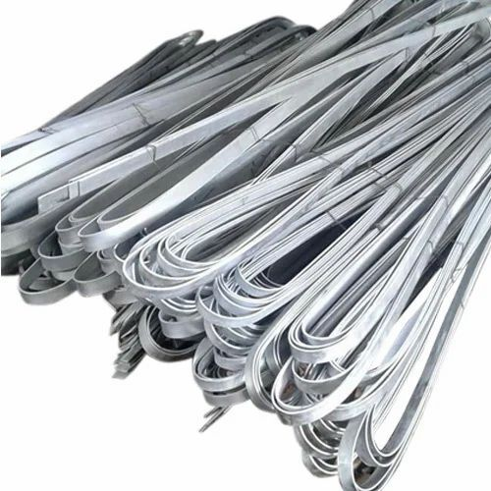
 | Cotton Rags |  | 15 Kg | KG | 
 | MS Square Pipe | 1 Inch x 1 Inch (Gauge=18) | 6 x20 Feet | Feet | 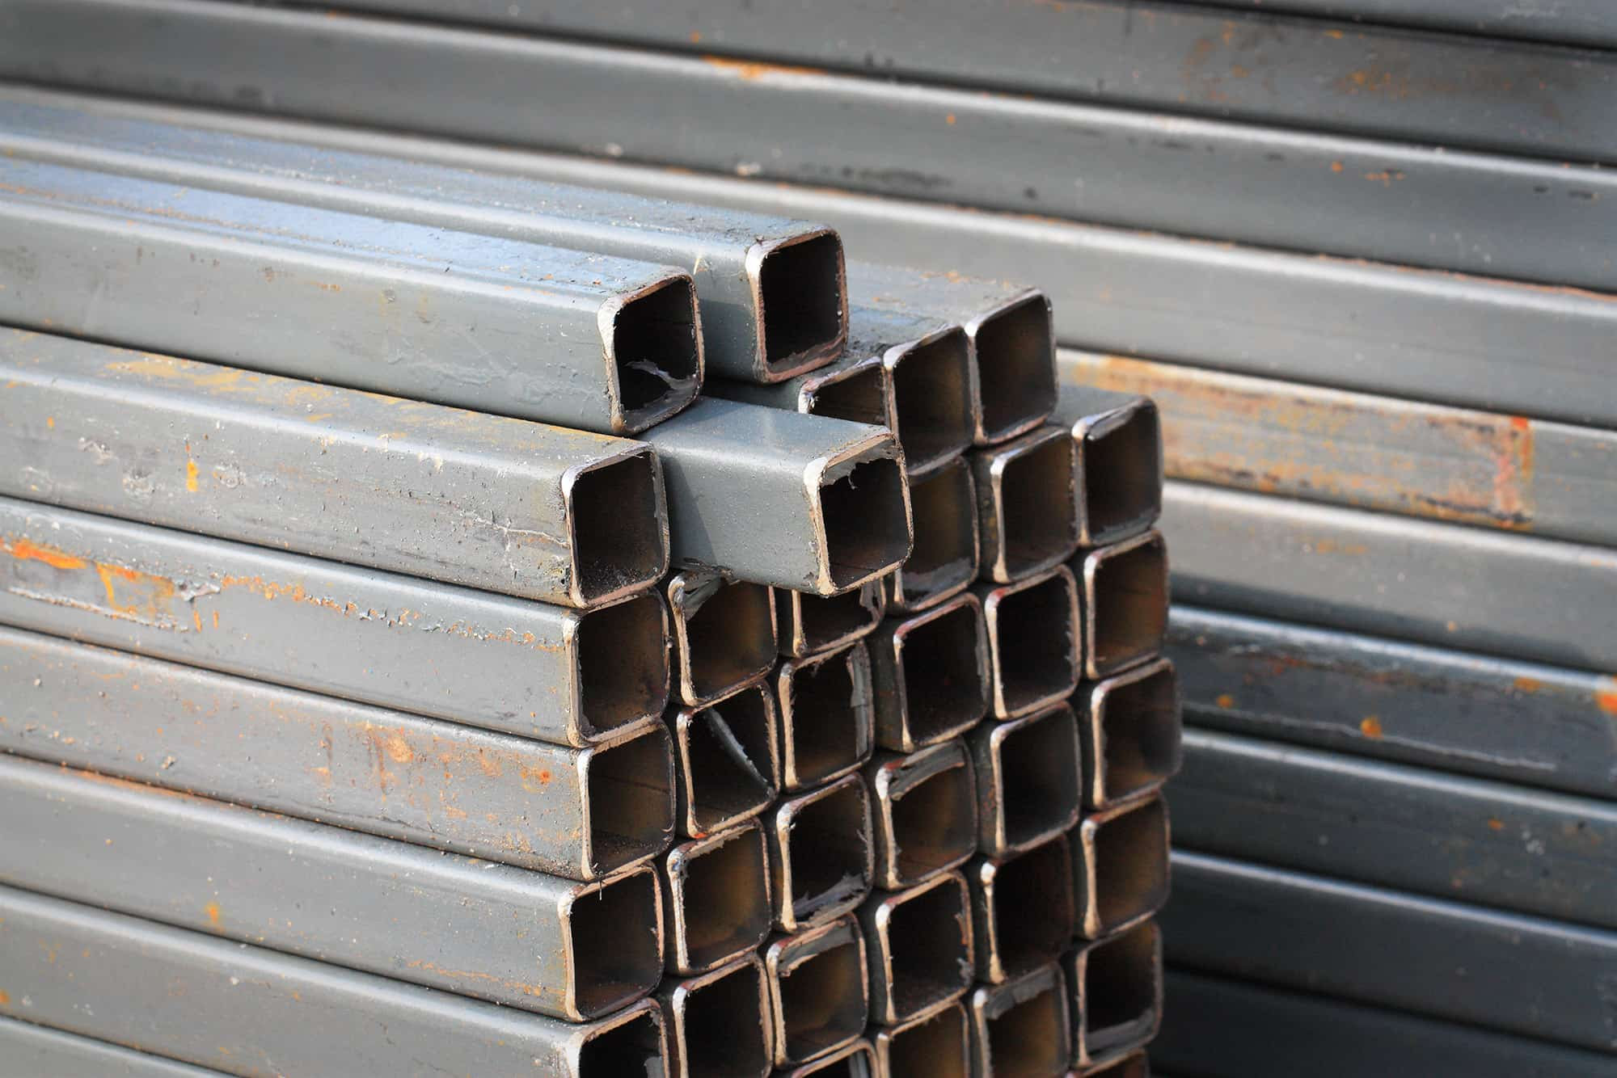
 | Banana Plug | 2mm | 61 Pieces | Nos | 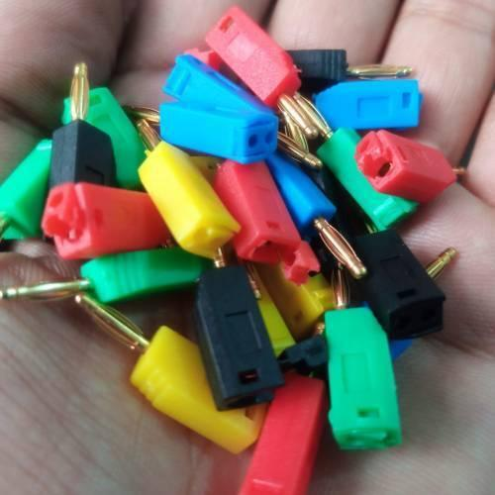
 | Insulation Electronic Jumper Wire Cable | Black, blue ,Green & Yellow | 6 Meter Each | Meter | 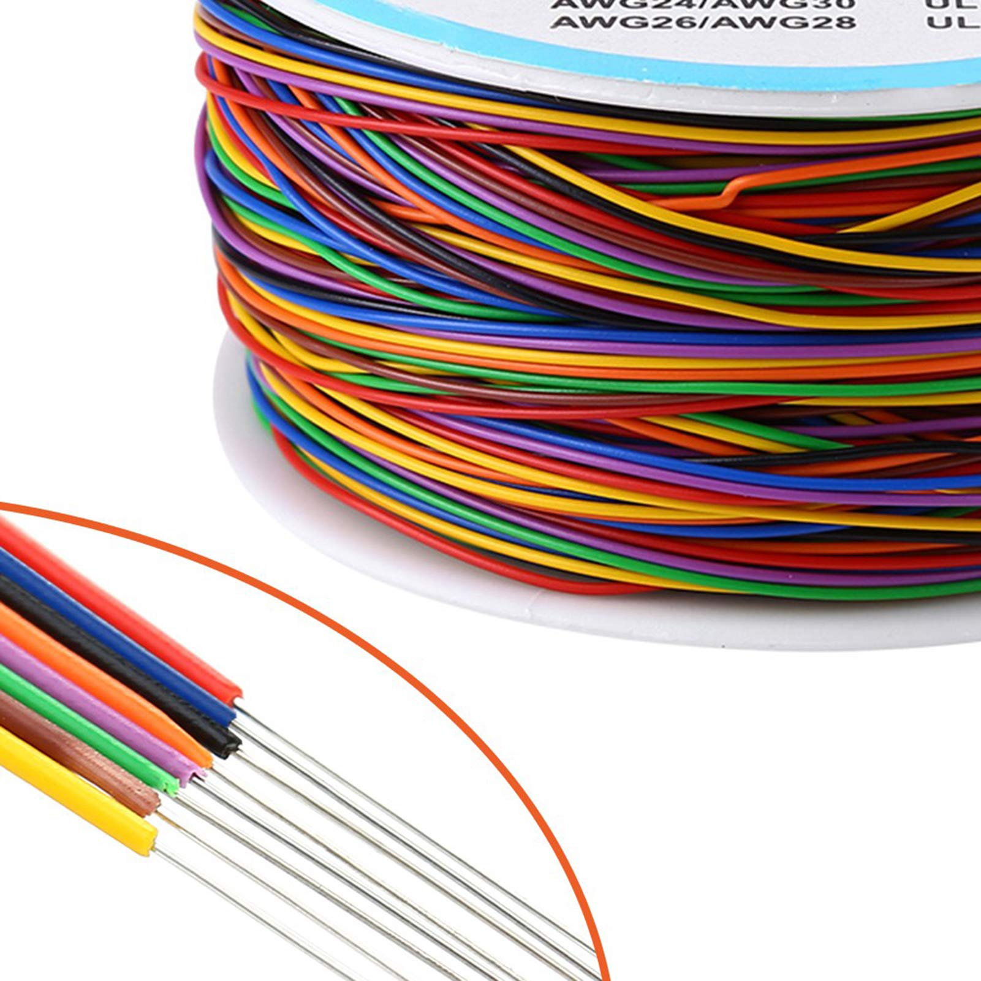
 | Power Plus Battery | 9V | 12 Pieces | Nos | 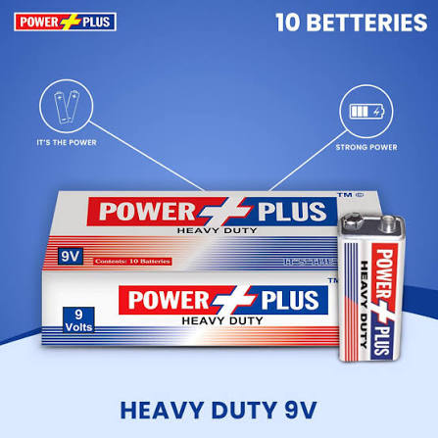
 | Acrylic sheet | 4 feet x 6 Feet (Thicknes =5mm) | 1 | Nos | 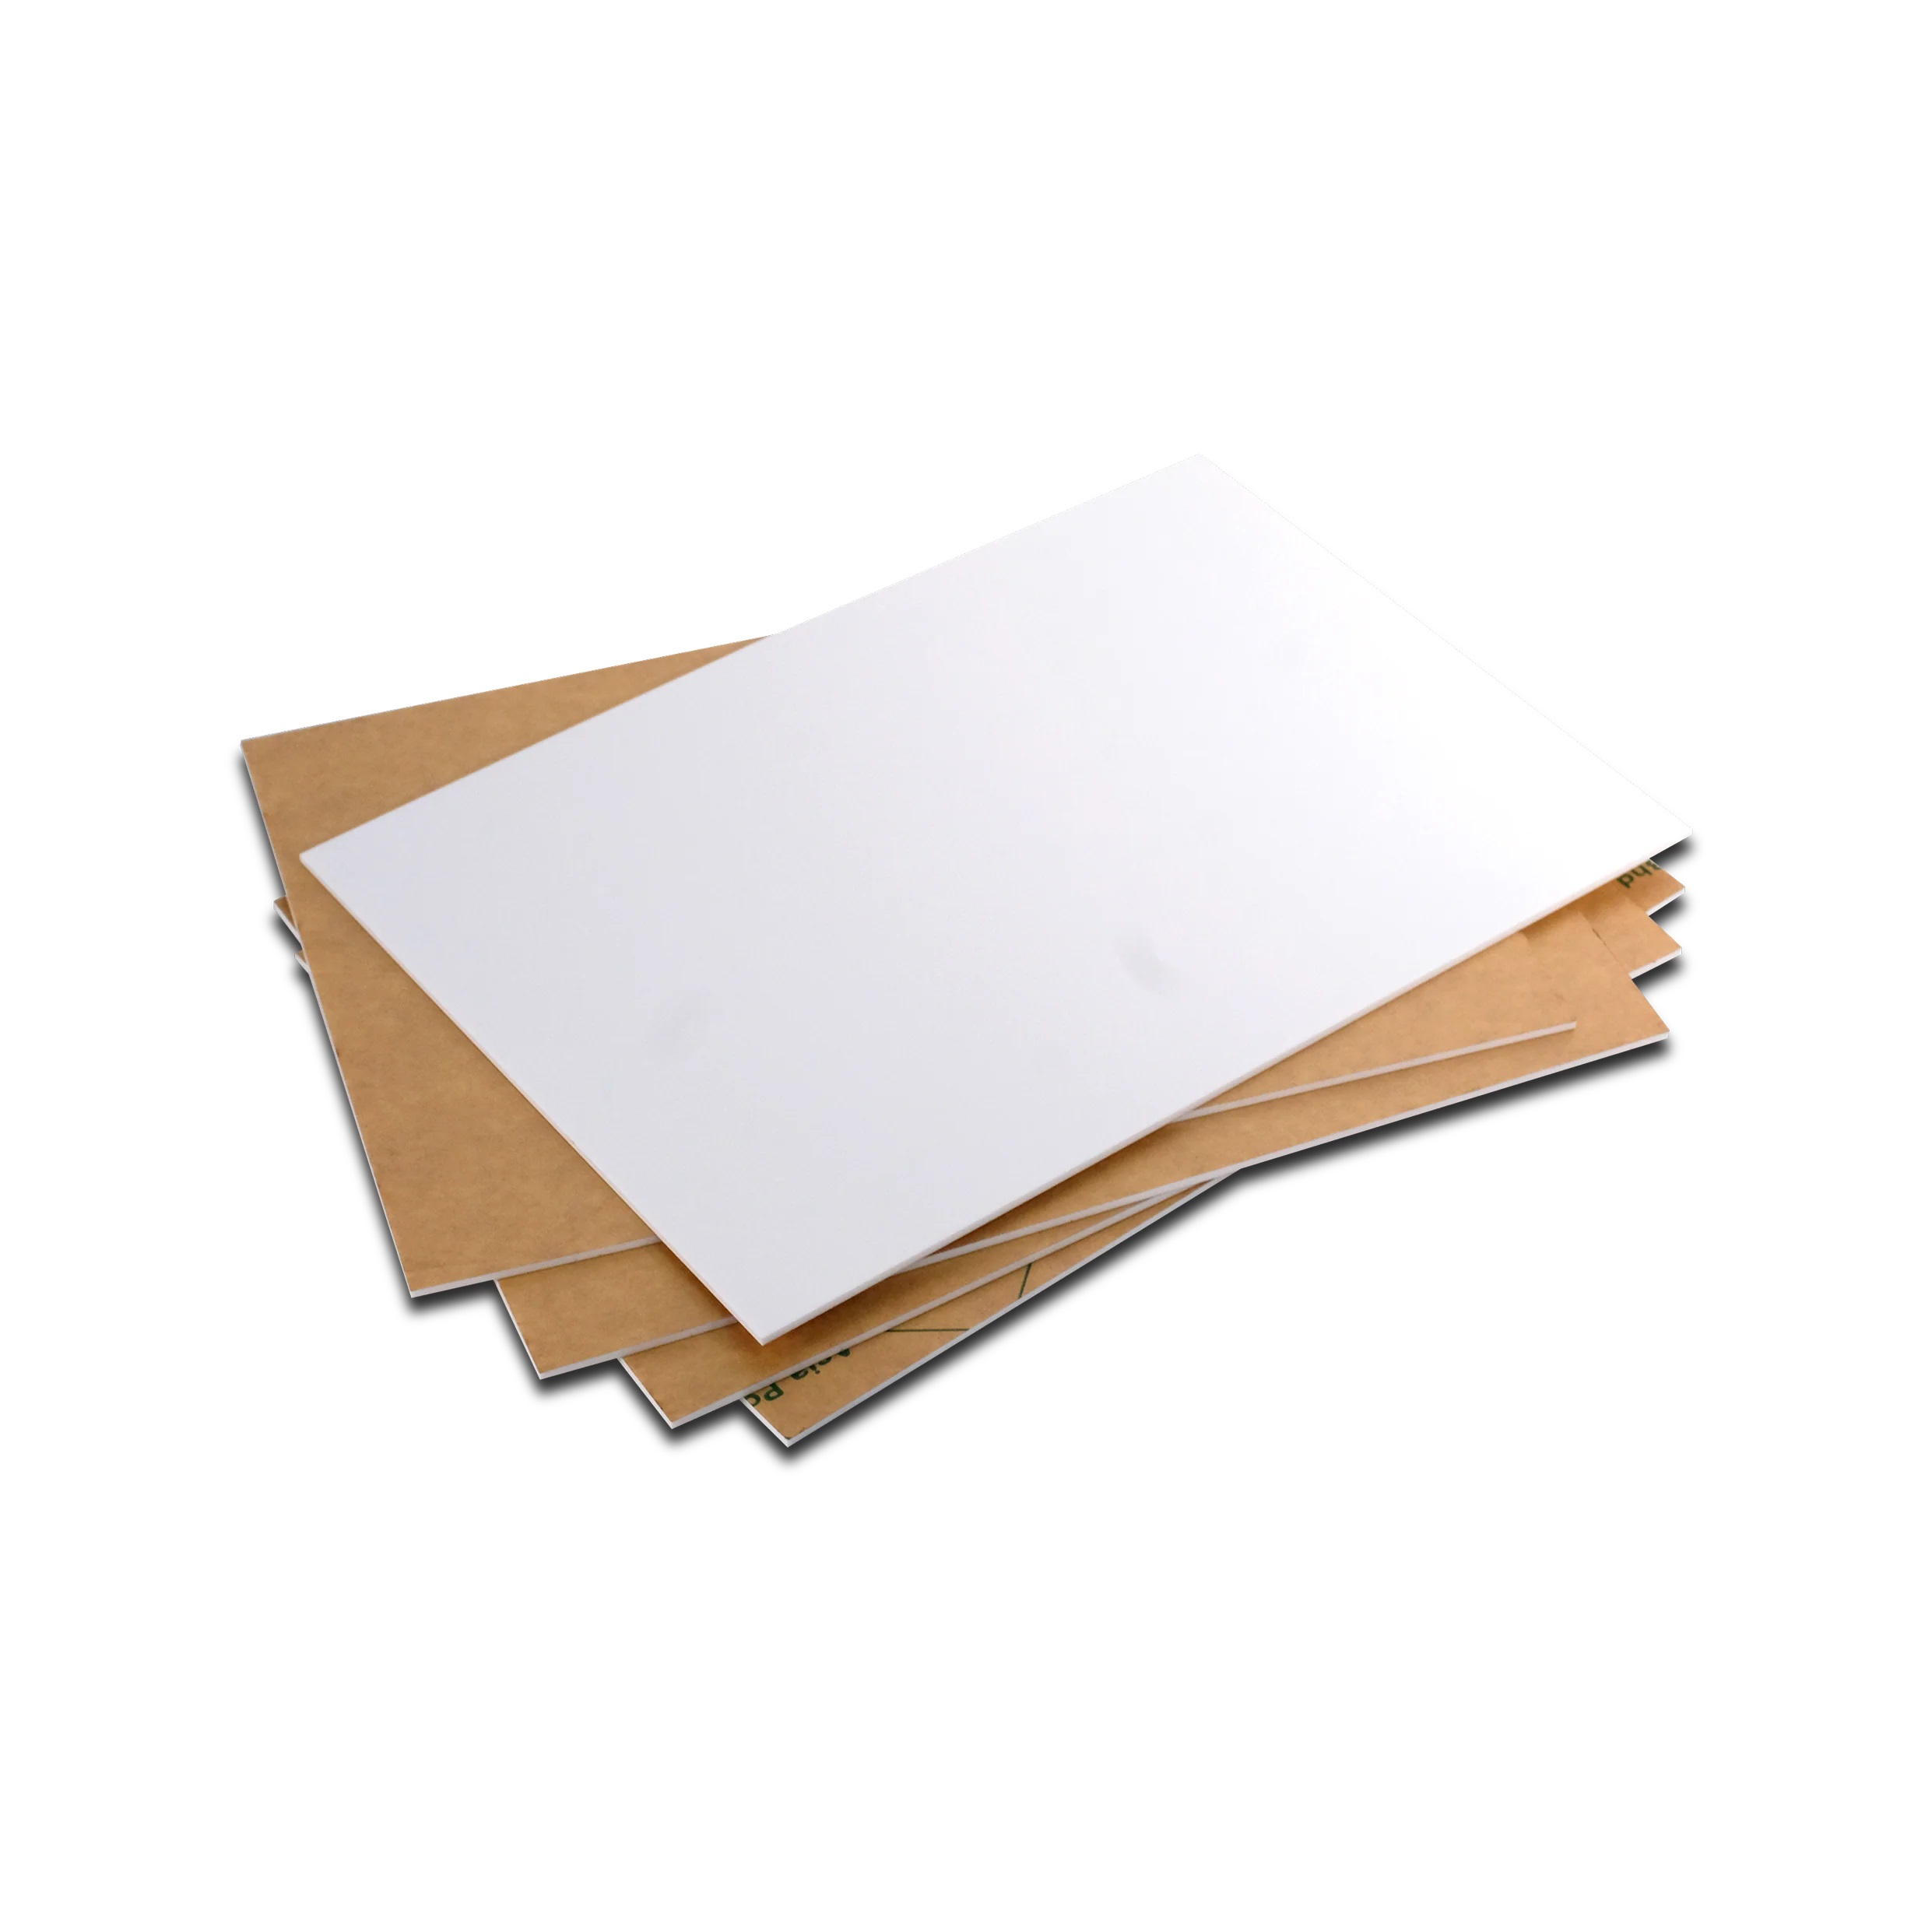
 | Teflon rods | Diameter =1.5 inches Length 5 Feet | 3 | Nos | 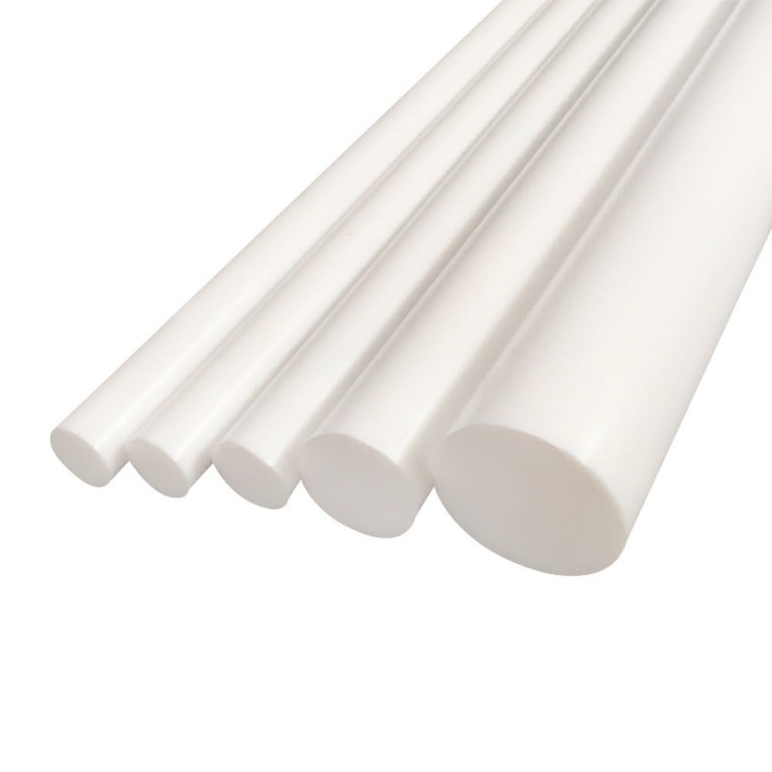
 | PLA Falament For 3d printer | Diameter=1.75mm | 1 kg Roll | KG | 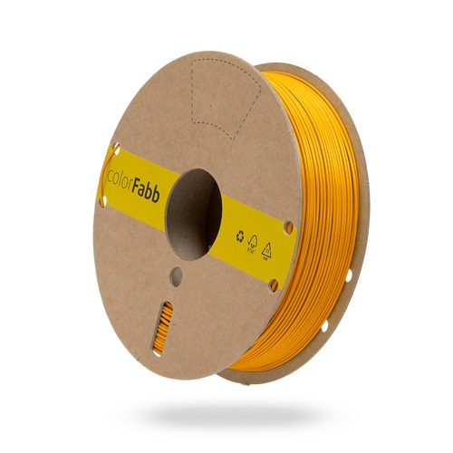

2. INSTRUCTIONS TO BIDDERS & COMMERCIAL TERMS
1. Submission on Vendor's Official Letterhead: Bidders MUST submit their complete technical details, unit prices, total amounts, and delivery lead times printed on their own official company letterhead, bearing valid FBR NTN, quotation reference number, date, authorized signature, and company stamp.
2. Inclusive Pricing Mandate: All quoted prices must be fully inclusive of all applicable government taxes, duties, freight, handling, and delivery charges to HITEC University Taxila. No separate tax addition or extra charges over and above the quoted prices shall be allowed under any circumstances.
3. Sealed Outer Envelope: Quotations must be delivered in a sealed envelope clearly marked: 'RFQ Ref No: HITEC/PROC/RFQ/2026/2868 — DO NOT OPEN BEFORE CLOSING DEADLINE' addressed to Manager Procurement, Procurement Branch, HITEC University Taxila.
4. Closing Deadline Strictness: Bids received after the submission deadline date and time will be rejected automatically.
5. Tax Eligibility & ATL Status: Only active taxpayers listed on FBR's Active Taxpayers List (ATL) with a valid NTN are eligible to participate. Applicable statutory taxes will be withheld at source as per Government rules.
6. Commercial Validity & Lead Time: Quoted prices must remain valid for a minimum of 30 Days from the closing date. Delivery lead time must be explicitly stated in calendar days on the quotation.
7. Payment Terms: 100% payment upon complete delivery, physical inspection, and issuance of Acceptance Certificate by University Inspection Committee.
8. Institutional Rights: HITEC University reserves the right to accept or reject any quotation, split quantities, or annul the procurement process without incurring liability.

ISSUED BY ORDER OF THE DIRECTOR ADMINISTRATION (HITEC UNIVERSITY TAXILA)
_____________________________________
Bilal Ahmed Shah / Manager Procurement
Date of Issuance: 15 October, 2026

